****Capture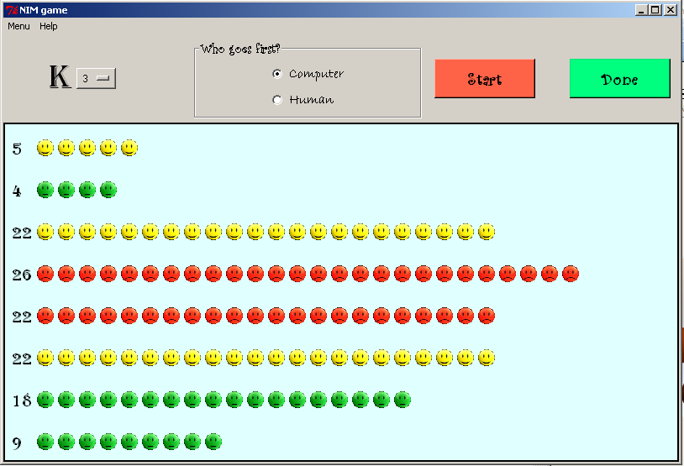

**About Nim**

Page 3: What is Nim?

History behind it

**Our version of Nim**

Page 4: Our python version

Example Game screen

**What our functions do?**

Page 5: Examples and pictures

Page 6: Examples and pictures (part 2)

**How to play Nim?**

Page: 7Who goes first?

Page: 8 Start the actual game!

Page: 9 Use the option menu

Page: 10 How to use the option menu?

Page: 11 Methods of removing stone(s)

Page: 11 Scenario# 1

Page: 12 Scenario# 2

Page: 13 Scenario# 3

Page: 14 Scenario# 4

**How to win?**

Page: 17 walkthrough of winning part 1

Page: 18 walkthrough of winning part 2

Page: 19 walkthrough of winning part 3

**In Conclusion**

Page: 20 Information center, including phone number and official website page

**What is Nim?**

Nim is an ancient game played by two people, where the two competitors alternate taking different amount of counters from the various piles given. The number of piles and stones can come in any amount and size. They can choose any number of counters as they wish, and the player that takes the last stone loses the game. The game has said to be originated from China from about the 1500’s and is still played at this time.

**History behind Nim:**

The theory of the game was discovered by a famous Italian mathematician named Charles Bouton in the early 1900s and he published his version of the game in 1902 while studying at Harvard University. He named it “Nim”, after an ancient word meaning “take!”

help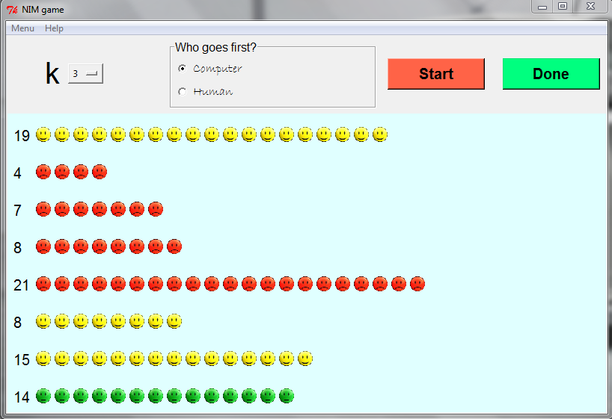**Python version of Nim:** The python version of the game consists of the same rules from the original game Nim, and it played using various controls and buttons shown below.

|  |  |
| --- | --- |
| startbuttonStart button :  donebuttonDone button:  menuoptionmenuOption menu:  Menu file:  radiobuttonCharacter  Radio buttons: | Help file:  scoreScore counter:  countersStones: |

|  |  |
| --- | --- |
| **Buttons/icons** | **description** |
| startbutton | The function of this button resets or starts a new game |
| radiobutton | A button which allows you to pick who goes first when starting a new game, (you or your computer) |
| donebutton | The function of this button ends your turn and also makes the computer play its move |
| optionmenu | This function lets you choose the number of piles you wish to take, only works once before the game begins |
| menu | A pull down menu which allows you to start a new game or exit the game |
| help | A pull down menu which allows you to see a brief summary about the game and shows you who created it. |
| score | This counts the number of stones for each row as the user and computer remove the number of stones from each pile. It is placed in 8 different rows. |
| snapshot25 | This icon represents the stones on the game screen, and comes in 3 different designs. The user must click any amount of these stones for his/her turn. |

**1.) Who goes first?**

*[Cursor Hand  Clip Art](javascript:edit(24688))*You have the power to choose who goes first, by using the “Who goes first”, radio buttons! The radio buttons is located at the top of the game platform, which has a Label frame named, “Who goes first”, and has the following options, “Computer” and “Human.” Click which one of you goes first on one of the radio buttons.

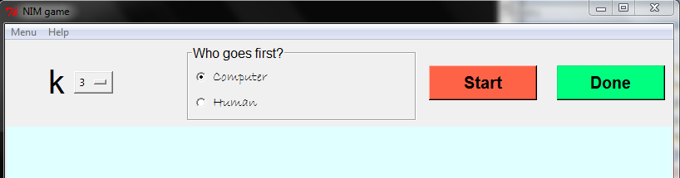

*\*if you want the computer to go first, click* ***“Computer”***

*\*if you want to go first, click* ***“Human”***

**2.) Start the actual game!**

[](javascript:edit(24688))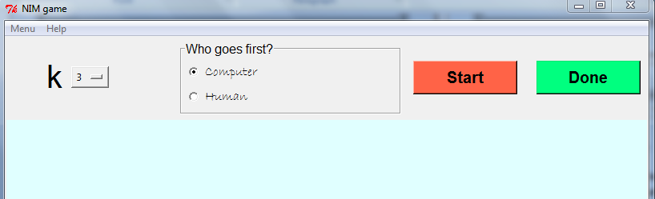After you have chosen who will be going first, start the game by pressing the “Start” button.

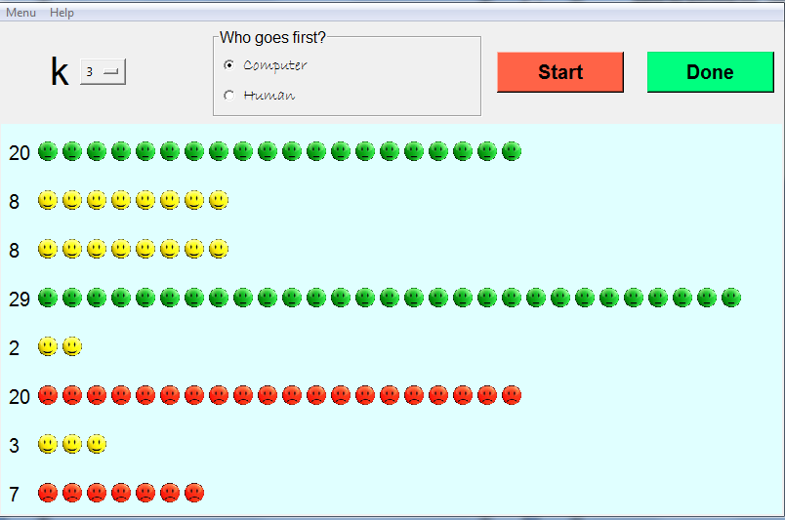*[Cursor Hand  Clip Art](javascript:edit(24688))*Once you have started the game, the stones will appear on the game screen in a random order as shown below.

**3.) Use the option menu**

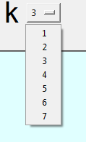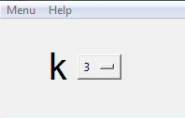In any version of Nim, a player can choose to pick as many of the stones as he/she desires, the number of stones to pick is unlimited. However, the number of piles a player can take is limited. The “k” options menu represents the number of piles a player can take in order to claim his/her stones. The maximum number of piles a player can obtain is 7 and the minimum is 1. The first thing you should do is to pick the number of piles you wish to take using the options menu; otherwise it will be set as default 3 once you start the game.

[Cursor Hand  Clip ArtCursor Hand  Clip Art](javascript:edit(24688))

***\*Warning you can only pick an option from the option menu once before you start the game!***

**How to use the Option menu**

Using the option menu is not as easy as it looks; because the point of that function lets you choose how many piles you wish to claim in order to pick any amount of stones. Once you claim the number of piles using the option menu, in the start of the game, there’s no turning back and changing it, unless you wish to restart the game.

To explain this more in depth look at these scenarios of the game played my (“player x” vs. his computer) on how you can pick stones from obtained piles in different ways...

**You must pick stone(s) from the piles you’ve clicked on!**

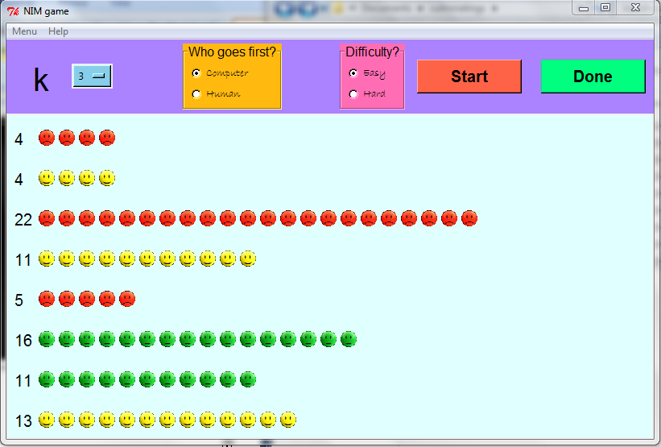For example the picture shown below has the value set to 3, “k = 3”. This means that “player x” can click on 3 different piles on his turn to remove stone(s), he chose to remove stones from the circled piles below.

**Methods for removing stones**

Scenario 1) **Pick all stones!**

You can pick any amount of stones as you wish as long as its from the 3 piles you have clicked from during you turn, otherwise it’s an invalid move!, For example “player x” picked all the stones from the 3 piles he clicked on

Scenario 2) **Pick from only 1 pile!**

 You can also just pick stone(s) from only one of the piles you clicked. The scenario shown below shows that “player x” just picked 2 stones from 1 obtained pile.

Scenario 3) **Pick one stone in total!**

You can even pick only one stone from any of the 3 piles you claimed on his move and just press “done”. The scenario shown below shows that “player x” picked only one stone on his move



Scenario4) **Go back to the previous piles**

You can also pick stones from the previous piles you’ve taken stones from. The picture shown below shows that “player x”, went back to the previous piles he’s clicked on (scenario 2) and removed the rest of the stones.

*\* You cannot press “Done”, until you pick stone(s) from any pile(s).*

*\* You can pick different piles during your next move, not during, so for example if you were in the situation of player x, where you picked those circled piles from the previous pages, you would have to stick with them until you press “done”, then you can pick different piles.*

4.) **Pick stone(s)**

Next you can remove as many stones as you like by clicking a stone that you want to remove while removing all the stones that are at the right of it.

[Cursor Hand  Clip Art](javascript:edit(24688))snapshot2For example, the picture showing below has a pile with 13 stones, so if you wish to remove 8 stones, count from the right side of the list to the left side from 1 to 8 until you land on a counter. Once you do click on the closest counter the mouse points on and it should remove all the counters from the one you clicked to all the other counters from the right of it.

Once you remove stone(s), the scoring value changes and represents the amount of stones left. So the picture below shows that there are 5 stones left after removing 8 stones. This makes sense because 13 – 8 =5.

[Cursor Hand  Clip Art](javascript:edit(24688))snapshot8*\*number of piles a player can take is unlimited!*

5.) **Finish your move!**

After you have played your move, press the button “Done”, located at the top of the game platform.

[Cursor Hand  Clip Art](javascript:edit(24688))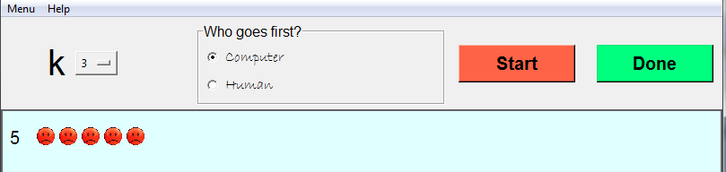

snapshot13snapshot12Once you press the button, the computer will automatically play its move. As you can see in the picture shown below, the computer has removed a number of stones from random number of piles.

snapshot14

**How do I win?**

In any game, playing a game is easy, but winning it is another story. To win this version of Nim on python, you need the computer to remove the last stone from the game screen.

**A Walkthrough on winning (1):**

There are various techniques of winning Nim. If you choose the easy version of Nim, winning the game should be a piece of cake! However if you choose the hard version of Nim, winning the game will take more than a couple of minutes to do so. Either way, a simple walkthrough should give you free pointers on how to beat the computer!

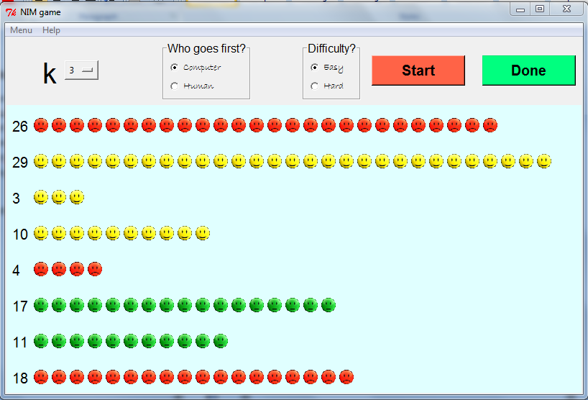 When you open the game screen, follow steps (1-4) in order to start the game.

**A Walkthrough on winning (2):**

Pick any amount of stones you like from various piles, as you normally would when you play the game.

When almost half the stones are removed or there are less stones afterwards, then you should try picking small amounts of stones possible, just in case. You can choose to pick more stones if necessary but doing that might jeopardize your chance of winning.

**Walkthrough on winning (3):**

If all goes well, and it comes down to the last pile, keep your wits up!

As shown below, there are 11 stones in the last pile you can pick from. This involves little thinking, because in order to win, the computer must remove the last stone from the pile. So what you should do is pick 10 stones from the pile, leaving the computer the last one. To do this count from the right side of the pile to the left from 1 to 10 until you land on a stone and click on it.

snapshot16

snapshot18snapshot17

And that is our quick tutorial on how the game Nim works on our python program. After reading all of these quick pointers and instructions, you should be able to properly play our game, with no hesitations.

If you have any more questions or concerns about our computer game, please call (905)-366-8076 or go on our official website [www.kapeeshanandyukigames.com](http://www.kapeeshanandyukigames.com), for more information.

MC900429829[1] Good luck to all of you players out there, and have fun!!